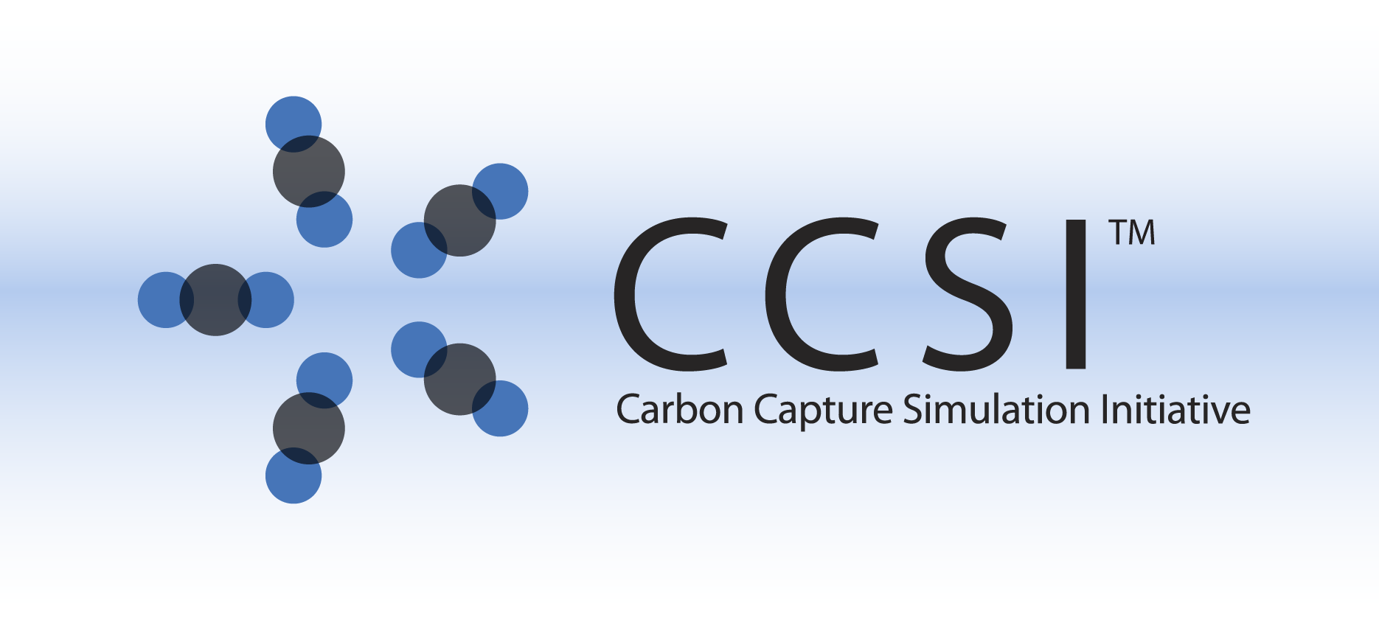

SUBGRID MODELS FOR DRAG AND HEAT TRANSFER IN

GAS-PARTICLE FLOWS

USER MANUAL

Version 2.0.0

March, 2018

William A. Lane1, Avik Sarkar2, Xin Sun2, Emily M. Ryan1, Sunkaran Sundaresan3

1Boston University, Boston, MA

2Pacific Northwest National Laboratory, Richland, WA

3Princeton University, Princeton, NJ

Copyright (c) 2012 - 2018

**Copyright Notice**

Filtered Models for Drag and Heat Transfer in Gas-Particle Flows was produced under the DOE Carbon Capture Simulation Initiative (CCSI), and is copyright (c) 2012 - 2018 by the software owners: Oak Ridge Institute for Science and Education (ORISE), Los Alamos National Security, LLC., Lawrence Livermore National Security, LLC., The Regents of the University of California, through Lawrence Berkeley National Laboratory, Battelle Memorial Institute, Pacific Northwest Division through Pacific Northwest National Laboratory, Carnegie Mellon University, West Virginia University, Boston University, the Trustees of Princeton University, The University of Texas at Austin, URS Energy & Construction, Inc., et al.. All rights reserved.

NOTICE. This Software was developed under funding from the U.S. Department of Energy and the U.S. Government consequently retains certain rights. As such, the U.S. Government has been granted for itself and others acting on its behalf a paid-up, nonexclusive, irrevocable, worldwide license in the Software to reproduce, distribute copies to the public, prepare derivative works, and perform publicly and display publicly, and to permit other to do so.

**License Agreement**

Filtered Models for Drag and Heat Transfer in Gas-Particle Flows Copyright (c) 2012 - 2018, by the software owners: Oak Ridge Institute for Science and Education (ORISE), Los Alamos National Security, LLC., Lawrence Livermore National Security, LLC., The Regents of the University of California, through Lawrence Berkeley National Laboratory, Battelle Memorial Institute, Pacific Northwest Division through Pacific Northwest National Laboratory, Carnegie Mellon University, West Virginia University, Boston University, the Trustees of Princeton University, The University of Texas at Austin, URS Energy & Construction, Inc., et al. All rights reserved.

Redistribution and use in source and binary forms, with or without modification, are permitted provided that the following conditions are met:

1. Redistributions of source code must retain the above copyright notice, this list of conditions and the following disclaimer.
2. Redistributions in binary form must reproduce the above copyright notice, this list of conditions and the following disclaimer in the documentation and/or other materials provided with the distribution.
3. Neither the name of the Carbon Capture Simulation Initiative, U.S. Dept. of Energy, the National Energy Technology Laboratory, Oak Ridge Institute for Science and Education (ORISE), Los Alamos National Security, LLC., Lawrence Livermore National Security, LLC., the University of California, Lawrence Berkeley National Laboratory, Battelle Memorial Institute, Pacific Northwest National Laboratory, Carnegie Mellon University, West Virginia University, Boston University, the Trustees of Princeton University, the University of Texas at Austin, URS Energy & Construction, Inc., nor the names of its contributors may be used to endorse or promote products derived from this software without specific prior written permission.

THIS SOFTWARE IS PROVIDED BY THE COPYRIGHT HOLDERS AND CONTRIBUTORS "AS IS" AND ANY EXPRESS OR IMPLIED WARRANTIES, INCLUDING, BUT NOT LIMITED TO, THE IMPLIED WARRANTIES OF MERCHANTABILITY AND FITNESS FOR A PARTICULAR PURPOSE ARE DISCLAIMED. IN NO EVENT SHALL THE COPYRIGHT OWNER OR CONTRIBUTORS BE LIABLE FOR ANY DIRECT, INDIRECT, INCIDENTAL, SPECIAL, EXEMPLARY, OR CONSEQUENTIAL DAMAGES (INCLUDING, BUT NOT LIMITED TO, PROCUREMENT OF SUBSTITUTE GOODS OR SERVICES; LOSS OF USE, DATA, OR PROFITS; OR BUSINESS INTERRUPTION) HOWEVER CAUSED AND ON ANY THEORY OF LIABILITY, WHETHER IN CONTRACT, STRICT LIABILITY, OR TORT (INCLUDING NEGLIGENCE OR OTHERWISE) ARISING IN ANY WAY OUT OF THE USE OF THIS SOFTWARE, EVEN IF ADVISED OF THE POSSIBILITY OF SUCH DAMAGE.

You are under no obligation whatsoever to provide any bug fixes, patches, or upgrades to the features, functionality or performance of the source code ("Enhancements") to anyone; however, if you choose to make your Enhancements available either publicly, or directly to Lawrence Berkeley National Laboratory, without imposing a separate written license agreement for such Enhancements, then you hereby grant the following license: a non-exclusive, royalty-free perpetual license to install, use, modify, prepare derivative works, incorporate into other computer software, distribute, and sublicense such enhancements or derivative works thereof, in binary and source code form. This material was produced under the DOE Carbon Capture Simulation.

**Revision Log**

|  |  |  |
| --- | --- | --- |
| **Version Number** | **Release Date** | **Description** |
| Version 2015.10.0 | 10/31/2015 | Updated Models and Cylinder-area calculations. More stable and accurate. |
| Version 2015.03.0 | 3/31/2015 | Update models for MFIX2014-1. Added limiter for stability. |
| Version 2.0.0 | 03/31/2018 | Initial Open Source release |

Table of Contents

1. Introduction 1

1.1. Motivating Example 1

2. Installation 2

2.1. System Requirements 2

2.2. Third Party Software 2

2.3. Product Usage 2

3. Test Case 3

3.1. Geometry 3

3.2. Subgrid Model Setup 4

3.3. Compiling and Running the Simulation 5

3.4. Verification 5

4. Example CaseS 7

5. Usage Information 8

5.1. Support 8

5.2. Restrictions 8

5.3. Next Steps 8

6. Debugging 9

6.1. How to Debug 9

6.2. Known Issues 9

6.3. Reporting Issues 9

7. References 9

List of Figures

Figure 1: Schematics of the test case: 3D domain with heat transfer cylinders (left), 2D cross-section domain with heat transfer cylinders (middle), and 2D cross-section domain with subgrid model (right), where DelP denotes a pressure drop in the vertical direction and IC denotes initial conditions. The dashed lines represent periodic boundaries. The gas-solid mixture is initialized inhomogeneously with IC(1), IC(2), and IC(3) to aid in mixing. 3

Figure 2: Transient domain-averaged solids temperature for the test case, shown in red. The temperature asymptotes to thermal equilibrium at 293 K and should be near 294 K after 10 seconds. A high-resolution control solution is given in black with the standard deviation denoted by gray shading. 7

Figure 3: Schematics of the bubbling fluidized bed example case: 3D original domain with heat transfer cylinders (left, cylinders not-to-scale), 3D domain with subgrid model (middle), and simplified 2D cross-section domain with subgrid model (right), where BC denotes boundary conditions and IC denotes initial conditions. The blue IC(2) section represents the porous media phase used to model the unresolved immersed cylinders. 8

List of Tables

# Introduction

Resolution of small-scale structures such as particle clusters and heat transfer cylinders is computationally impractical for large-scale devices. The inability to resolve these small-scale structures results in erroneous simulation predictions.

To enable accurate macroscopic predictions using coarse-grid simulations, subgrid filtered models are developed. These filtered models account for the presence of unresolved physics (e.g., drag [1] and heat transfer [2]) and geometry via constitutive subgrid equations.

This product is an implementation of theses subgrid models for: (1) cylinder-suspension drag [1],   
(2) cylinder-suspension heat transfer [2], and (3) gas-particle interphase drag in MFIX [3]. The   
cylinder-based models are valid for an array of horizontal tubes immersed in the flow. In the simulations, the cylinders are replaced by an effective stationary porous media, occupying the same volume as the cylinders. The drag [1] and heat transfer [2] are modified through source terms added to the governing equations.

## Motivating Example

Consider a laboratory-scale 1 MW fluidized bed reactor measuring 1.33 × 6.88 m, with horizontal heat transfer cylinders of 1 cm diameter and solid-particles with a mean diameter (*dp*) of 118 µm. Typically this system would be discretized into a fine-mesh with grid cells of 10 × *dp* = 1.2 mm, resulting in a system of approximately 6.35 million cells. Alternatively, using a subgrid filtering approach and setting the (coarse) cell size to 156.8 × *dp* = 1.85 cm results in a system of 26,784 cells, a significant reduction.

# Installation

These products do not require explicit installation; however, the user is required to have MFIX [3] made on their system to utilize the models. **Note:** These products were developed using source files from MFIX release 2015-1. Due to changes in the MFIX software structure, these models are not guaranteed to be backwards compatible with previous MFIX releases. To ensure proper functioning please use MFIX 2015-1.

## System Requirements

These products require MFIX [3].

## Third Party Software

Open-source, multi-platform data analysis, and visualization application *ParaView* is recommend for post-processing of the MFIX simulation and can be downloaded from [http://paraview.org](http://paraview.org/). Other similar visualization software (for example, Tecplot, VisIt) can also serve the same purpose.

## Product Usage

It is assumed that the user has built the required MFIX source files and created the entire MFIX directory, as detailed in [3].

To use the filtered models, ensure the following model files (found in model) are in the *local* run directory (in addition to the mfix.dat input file):

check_data/check_solids_continuum.f

drag_gs.f

drag_ss.f

init_namelist.f

namelist.inc

run_mod.f

set_outflow.f

solve_energy_eq.f

source_u_s.f

source_v_s.f

In addition to the standard MFIX keywords, the subgrid filtered models require the following keywords as shown in Table 1.

Table : MFIX Keywords for the Subgrid Models

| Keyword | Type |
| --- | --- |
| **SG_CYL_HYDRO**  Flag for turning on/off the hydrodynamics (drag) subgrid model. | LOGICAL |
| **SG_CYL_ENERGY**  Flag for turning on/off the energy subgrid model (requires hydrodynamics model). | LOGICAL |
| **SG_CYL_D**  Cylinder diameter in cylinder subgrid model. | DOUBLE PRESISON |
| **SG_CYL_a**  Cylinder spacing in cylinder subgrid model. Refer to [1] for definition of spacing. | DOUBLE PRESISON |
| **SG_CYL_T**  Cylinder surface temperature in cylinder subgrid model. | DOUBLE PRESISON |

Follow the MFIX instructions [3] to build the MFIX executable in the *local* run directory. Upon successful compilation, an mfix.exe executable is created in the *local* run directory.

# Test Case

## Geometry

To ensure the subgrid models are functioning correctly, a simple test case is includes. The test case is a 2D periodic domain simulating flow over two cooling cylinders. The mixture is initialized to a hot temperature and after some time the system reaches a thermal equilibrium equal to the cooling cylinders. The domain geometry is shown in Figure 1.

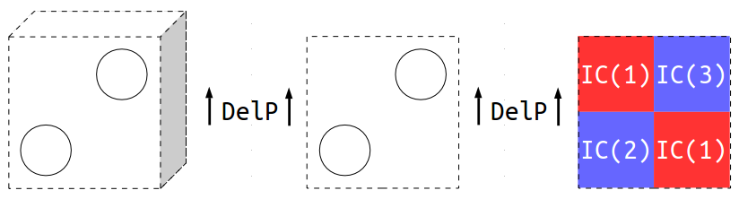

Figure : Schematics of the test case: 3D domain with heat transfer cylinders (left), 2D cross-section domain with heat transfer cylinders (middle), and 2D cross-section domain with subgrid model (right), where DelP denotes a pressure drop in the vertical direction and IC denotes initial conditions. The dashed lines represent periodic boundaries. The gas-solid mixture is initialized inhomogeneously with IC(1), IC(2), and IC(3) to aid in mixing.

## Subgrid Model Setup

The subgrid models employ a secondary solid phase as a stationary porous media to occupy the volume of the unresolved cylinders. As a result, a second solid phase must be defined in the mfix.dat input file. The properties are arbitrary and are not used in any calculations; however, if they are highly unphysical, MFIX can error out. The property values below are recommended.

NMAX_s(2) = 1 # number of species

RO_s0(2) = 1.0 # density (kg/m^3)

D_p0(2) = 1.0 # particle diameter (m)

K_s0(2) = 0.1 # thermal conductivity (W/kg.K)

C_ps0(2) = 1000.0 # specific heat capacity (kJ/kg.K)

MW_s(2,1) = 1.0 # molecular weight (g/mol)

The stationary solids phase-fraction is set equal to the volume fraction occupied by the cylinders:

$$IC_EP_s(1,2)=\frac{π⋅{SG_CYL_D}^{2}}{2⋅{SG_CYL_a}^{2}} \\ =\frac{π⋅{0.01}^{2}}{2⋅{0.03}^{2}}⋅1 \\ =0.174.$$

Similarly, the average gas and solids (moving phase) fractions are calculated based on the remaining unoccupied volume, i.e., $1-IC_EP_s(1,2)$:

$$IC_EP_g'=\left(1-IC_EP_s\left(1,2\right)\right)⋅EP_g_{0} \\ =\left(1-0.174\right)⋅0.7 \\ =0.578$$

$$IC_EP_s'=\left(1-IC_EP_s\left(1,2\right)\right)⋅EP_s_{0} \\ =\left(1-0.174\right)⋅0.3 \\ =0.248.$$

It is important to ensure that the sum of the gas and solids fractions equal one, otherwise MFIX will error out. The inhomogeneities are introduced into the system by splitting the domain into four different sections and offsetting the gas and solid fractions, ensuring the average is still correct.

$$\left.\begin{matrix}IC_EP_g\left(1\right) =IC_EP_g'+0.05=0.628 \\ IC_EP_s(1,1)=IC_EP_s'-0.05=0.198 \end{matrix}\right\} red regions shown in Figure 1$$

$$\left.\begin{matrix}IC_EP_g\left(2\right) =IC_EP_g'-0.05=0.528 \\ IC_EP_s(2,1)=IC_EP_s'+0.05=0.298 \end{matrix}\right\} bottom-right blue region shown in Figure 1$$

$$\left.\begin{matrix}IC_EP_g\left(3\right) =IC_EP_g'-0.05=0.528 \\ IC_EP_s(3,1)=IC_EP_s'+0.05=0.298 \end{matrix}\right\} top-right blue region shown in Figure 1$$

The new subgrid keywords must be set according to the desired physics and geometry:

SG_CYL_HYDRO = .TRUE.

SG_CYL_ENERGY = .TRUE.

SG_CYL_D = 0.01

SG_CYL_a = 0.03

SG_CYL_T = 293.0

## Compiling and Running the Simulation

Recompile MFIX (as instructed in Section 2.3 Product Usage) using the following Bash commands:

1. cd PATH_TO/test/ # change directory to test/
2. cp –r ../model/* . # copy model files (recursively) to run directory, test/
3. sh $MFIX/model/make_mfix # make MFIX, recompile with local source files, where $MFIX is the location of mfix/
4. mpirun –np $NSLOTS mfix # execute simulation in parallel, where $NSLOTS is the number of processors (i.e., NODESI*NODESJ*NODESK)

## Verification

To verify that the subgrid models are working correctly, the data must be post processed using MFIX’s included program, Post MFIX:

1. cd PATH_TO/test/ # change directory to test/
2. cd $MFIX/post_mfix # change directories to mfix/
3. ./make_post # compile Post MFIX
4. cd - # change directories back to test/
5. sh $MFIX/post_mfix/post_mfix

The user will be prompted to enter several parameters, use the same inputs as below in red:

Enter the RUN_NAME to post_process > **TEST**

********************************************************

read_res0 : code valid for running on 1 processor only

********************************************************

after call to calc distance

after call to calc_vol

*************************************************

0 - Exit POST_MFIX

1 - Examine/print data

2 - Write .RES from data in .SPx files

3 - Write .RES for a new grid, using old data

4 - Calculate miscellaneous quantities

5 - Print out variables

6 - Call user defined subroutine USR_POST

7 - Write a new SPx file with selected records

8 - Write new SPx files with time averaged data

9 - Perform ORNL calculations

10 - run scavenger code

*************************************************

Enter menu selection > **1**

Interactive data retrieval program. Type ? any time for help,

or press RETURN to select default values shown in parenthesis.

Write output using user-supplied precision? (T/F) **F**

Time: ( 0.000, 0.000) > **0,10**

Time average ? (N) > **N**

Variable: (EP_g ) > **T_s**

Solids phase: ( 1) > **1**

I range: ( 1, 1) > **2,31**

Average or sum over I? (N) > **Y**

J range: ( 1, 1) > **2,31**

Average or sum over J? (N) > **Y**

K range: ( 1, 1) > **1,1**

File: (* ) > **T_s.txt**

The post processor will write the domain-averaged solids temperature to an output file, T_s.txt. Open this file with any plotting software and plot the transient temperature. It should asymptote towards 293 K and be near 294 K by *t* = 10 seconds.

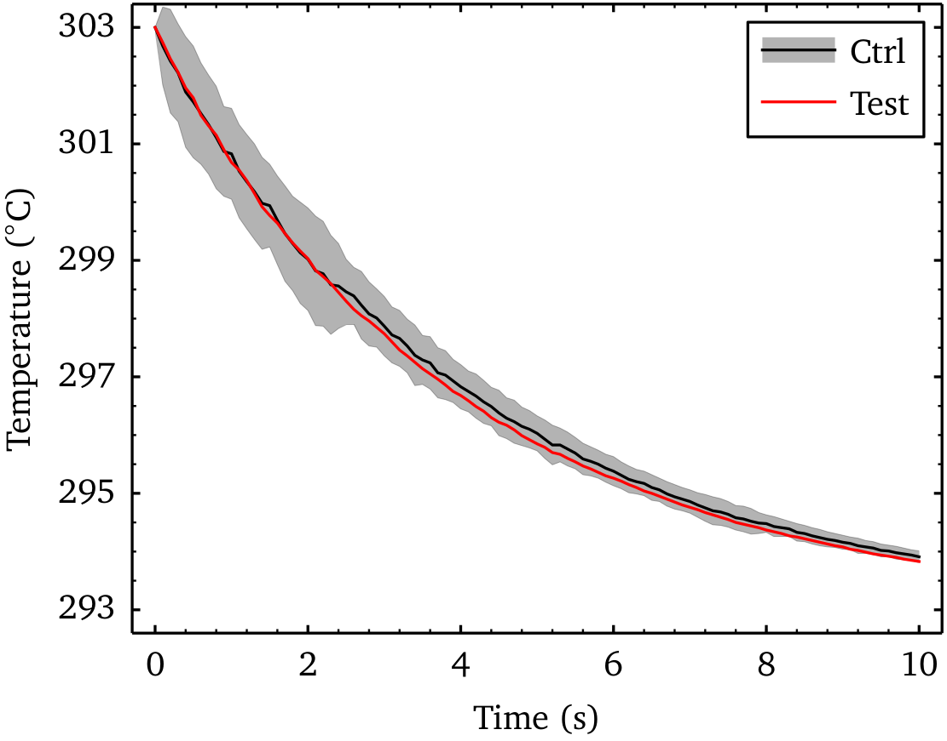

Figure : Transient domain-averaged solids temperature for the test case, shown in red. The temperature asymptotes to thermal equilibrium at 293 K and should be near 294 K after 10 seconds. A high-resolution control solution is given in black with the standard deviation denoted by gray shading.

# Example CaseS

Two example cases of a heated fluidized bed has been included with the release of this product. Example1 demonstrates the system with non-reacting heated flow, employing the subgrid models for the hydrodynamics and heat transfer. Example2 utilizes the same system and includes reacting flow, simulating the adsorption of carbon dioxide onto solid sorbent particles. The following section describes these examples.

The geometry is based on the motivating example from Section 1.1 Motivating Example. The domain measures 1.33 × 6.88 m, with 1 cm diameter heat transfer cylinders (modeled as a porous media). The initial bed is empty. There is mass-inflow of particles and gas at the downchute that fill the reactor and a mass-inflow of gas at the base for fluidization. The mass-inflows are equalized by a mass-outflow area on the side for gas and solids and a pressure outlet above the freeboard. The walls are set to free-slip boundary conditions. Details can be found in the mfix.dat input files.

To compile and run the example case, refer to Section 3.3 Compiling and Running the Simulation.

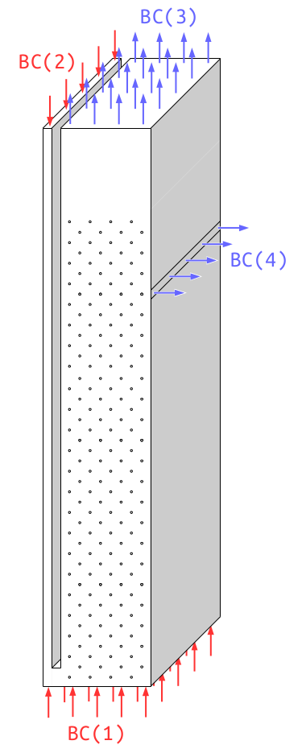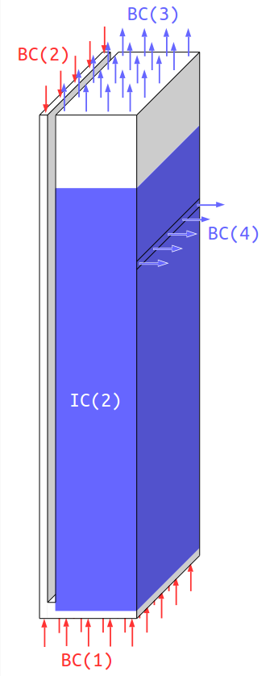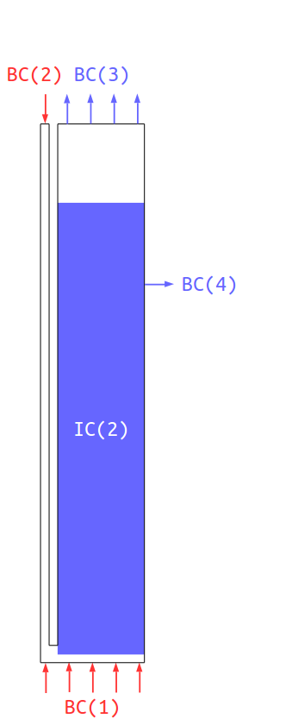

Figure : Schematics of the bubbling fluidized bed example case: 3D original domain with heat transfer cylinders (left, cylinders not-to-scale), 3D domain with subgrid model (middle), and simplified 2D cross-section domain with subgrid model (right), where BC denotes boundary conditions and IC denotes initial conditions. The blue IC(2) section represents the porous media phase used to model the unresolved immersed cylinders.

# Usage Information

## Support

For technical support, send an e-mail to [ccsi-support@acceleratecarboncapture.org](mailto:ccsi-support@acceleratecarboncapture.org) and/or fill out the “Submit Feedback/Request Support” form available on the product distribution page.

## Restrictions

This model does not support multiple solid-phases and requires the use of the Wen-Yu drag model. These models have not been verified in 3D.

## Next Steps

The model is undergoing verification/validation and uncertainty quantification.

# Debugging

Please refer to the following sections for debugging instructions and help contacts.

## How to Debug

The cylinder-suspension drag model is largely implemented in drag_gs.f, drag_ss.f, source_u_s.f, and source_v_s.f, while the heat transfer model is largely implemented in solve_energy_eq.f. If the user is encountering errors, debug the problem systematically. Begin by simplifying the system and physics, and then systematically add in more details and physics. Once the problem is identified, refer to the aforementioned files for easy locating of bugs.

## Known Issues

Energy conservation problems were observed with MFIX 2015-2 and periodic domain simulations.

## Reporting Issues

To report an issue, please send an e-mail to [ccsi-support@acceleratecarboncapture.org](mailto:ccsi-support@acceleratecarboncapture.org).

# References

[1.] A. Sarkar, X. Sun, S. Sundaresan, “Sub-grid drag models for horizontal cylinder arrays immersed in gas-particle multiphase flows.” *Chemical Engineering Science*, vol. 104, 18, pp. 399–412,   
December 2013.

[2.] W.A. Lane, E.M. Ryan, A. Sarkar, S. Sundaresan, “Sub-grid models for heat transfer in   
gas-particle flows with immersed horizontal cylinders,” *Chemical Engineering Science*, (submitted).

[3.] S. Benyahia, M. Syamlal, T.J. O’Brien, “Summary of MFIX Equations 2012-1”, From URL <https://mfix.netl.doe.gov/documentation/MFIXEquations2012-1.pdf>, January 2012.